Environmental Policy Statement

Western Electrical Contractors Ltd are committed to complying with all current relevant legislation regarding the environmental safety and industry codes of practices. We are committed to providing unparalleled standards and quality of service to all of its customers. We believe this can and must be done in a way which protects and enhances the environment
Within our business activities we will endeavour to set an example of responsible environmental Management and Conservation, including active re-cycling of materials wherever practicable.
We are committed to protecting the environment and will act to achieve the following:

- Ensure that we comply with all Environmental Legislation, Regulations, and other Requirements to which the Company subscribes.
- Reduce waste levels and actively recycling waste materials for re use.
- Awareness and use of appropriate technology for the conservation of energy
- Adhere to a purchasing procedure which considers environmental impacts
- Minimise the use of non-sustainable natural resources
- Minimise waste through an effective waste management system
- Prevention of pollution and sustainable use of resources
- Training employees and raising awareness with procedures and responsibilities
- Ensuring activities are carried out with minimal impact on local communities and not creating a nuisance to our neighbours
- Protection of Biodiversity and Ecosystems
- Continually improve, with the assistance of all our staff with our environmental performance.
- Ensuring that all personnel are aware of our policy and the potential impacts of their activities on the environment.
- This policy is communicated to the public, other interested parties including those working on behalf of the Company and contractors.

This policy will be reviewed to ensure that it is continuing to meet the company’s commitment to quality.

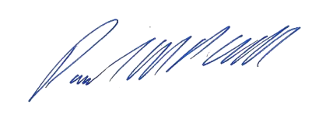

_________________
Paul Cull – Managing Director

08/06/2025

